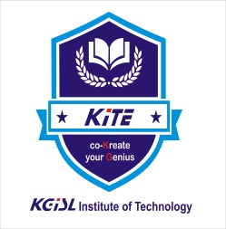

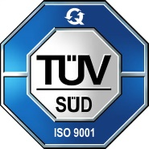
KGISL INSTITUTE OF TECHNOLOGY
(Approved By AICTE, Affiliated to Anna University, Chennai)
# 365, KGiSL Campus, Thudiyalur Road, Saravanampatti, Coimbatore-641035

NATIONAL CADET CORPS (NCC)

ANNUAL REPORT
2022 - 2023

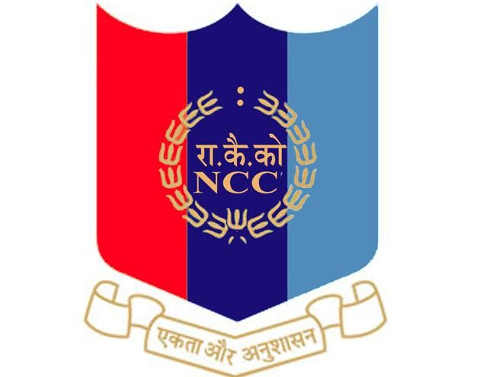

4 TAMIL NADU BATALLIAN NCC, COIMBATORE
INTERNATIONAL CYCLE DAY
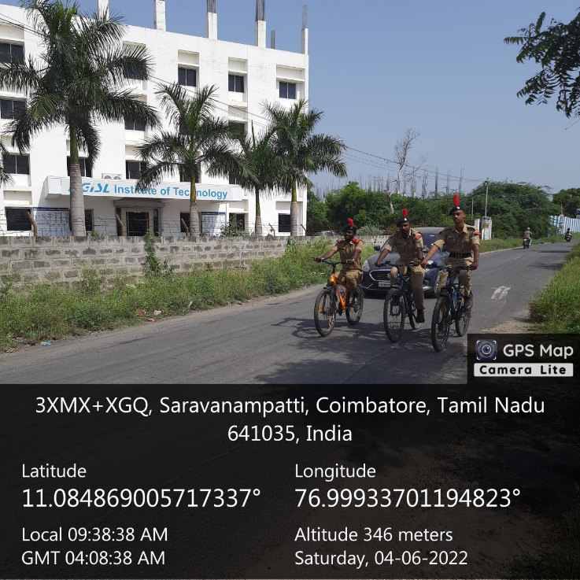
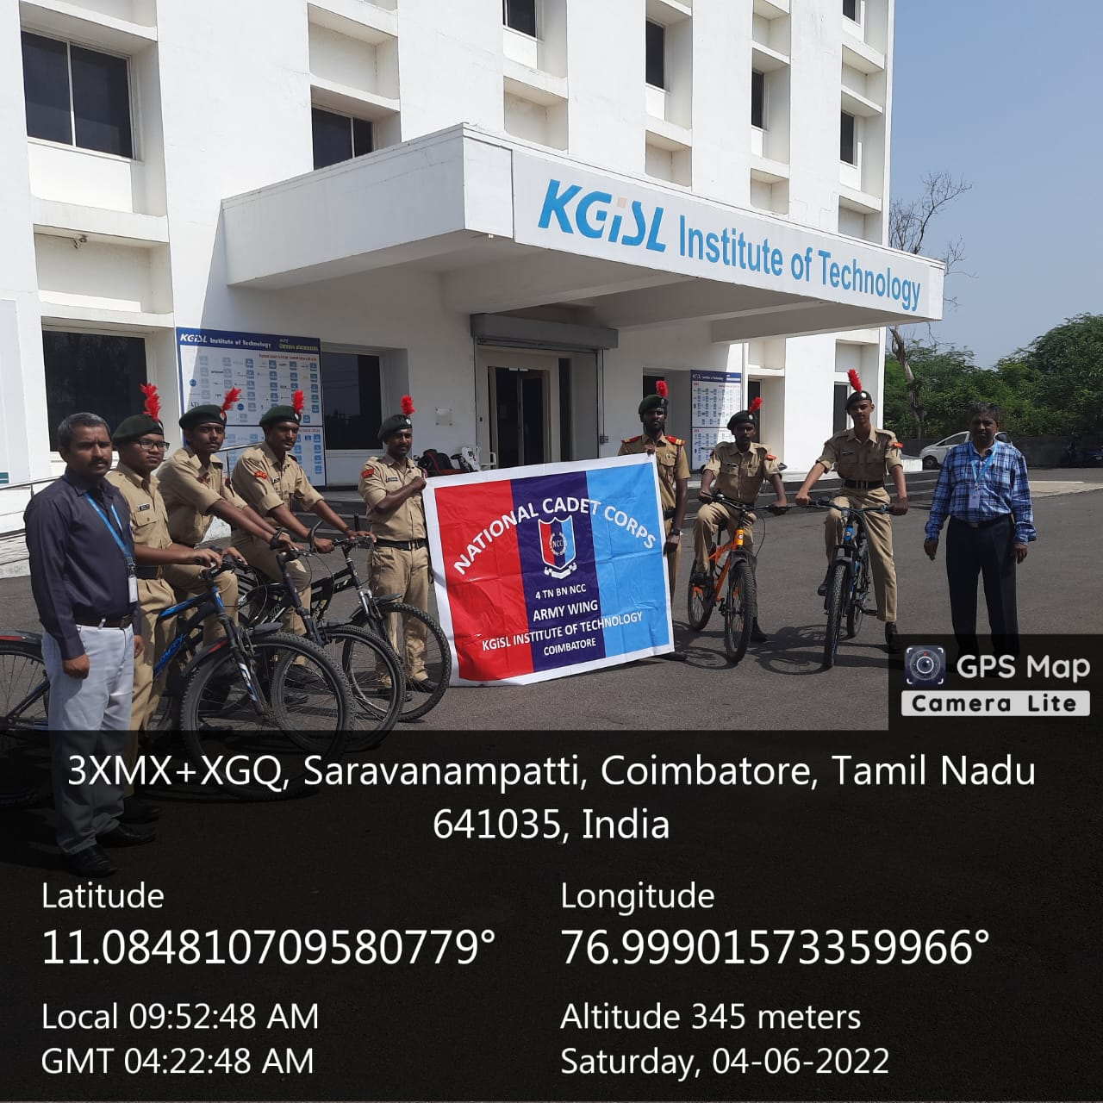
KITE NCC is organizing a cycle rally from saravanampatti to keeranatham route on 04-06-2022. The aim of the rally is to raise awareness for the message of clean India, Green India. The rally aims to support the initiative Swachh Bharat Abhiyan which was launched by Prime Minister Narendra Modified. NCC has been an important part of the movement of cycle rally.
International Cycle Day, 04 June 2022

INDEPENDENCE DAY
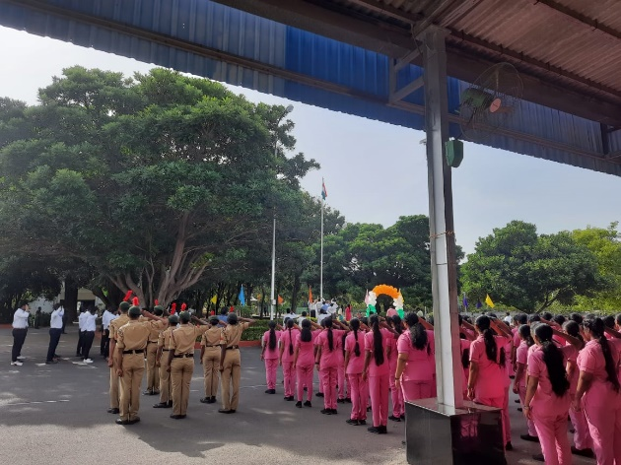
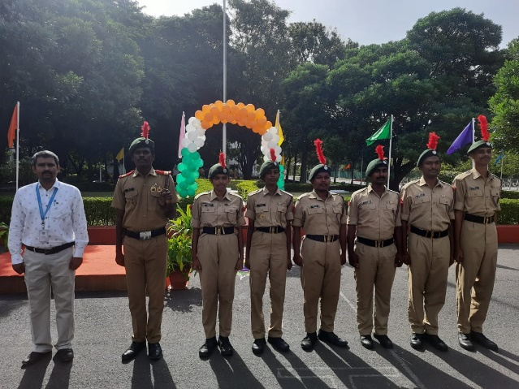
Every year Independence Day celebration is done in our college premises. Being an NCC cadet we must celebrate Independence Day to respect our patriotism. NCC unit of our college plays an important part in Independence Day celebration. NCC cadet have special practice for Independence Day celebration. Piloting for the guests, commanding preparation, band set practices and seniors reporting are the practices done by NCC careers as a preparation of Independence Day.
NCC RANK PROMOTION

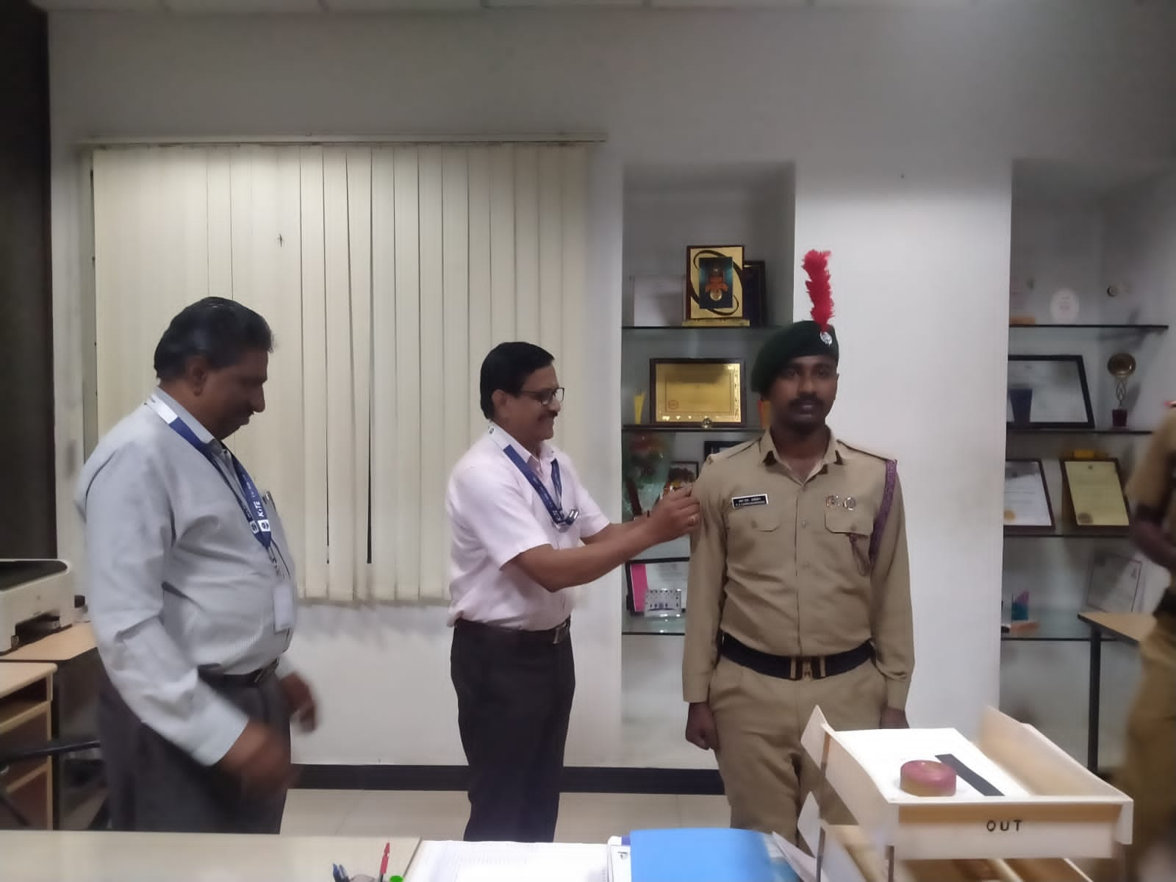
On November 11, 2022, the rank promotion ceremony for the NCC army wing was conducted, wherein Dr. M. Selvam, Principal, KITE was the chief guest and Mr. D. Manikandan, Administrative Officer-KITE & Ex-Army Officer was special guest. Some of the cadets were promoted to higher ranks for their hard-work, and dedication towards the organisation.
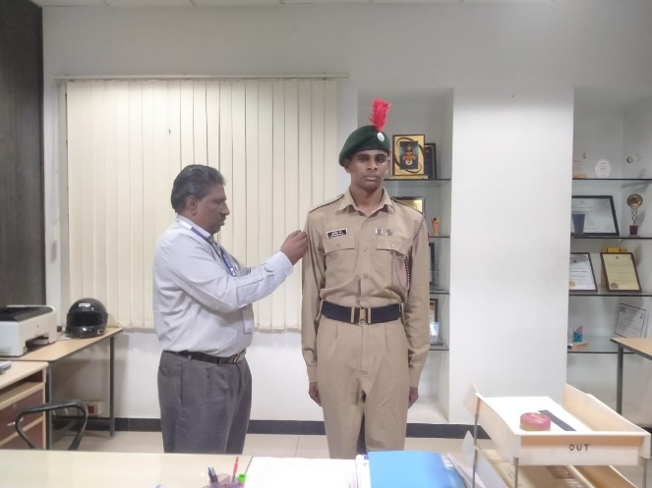
NCC Rank Promotion

NCC DAY
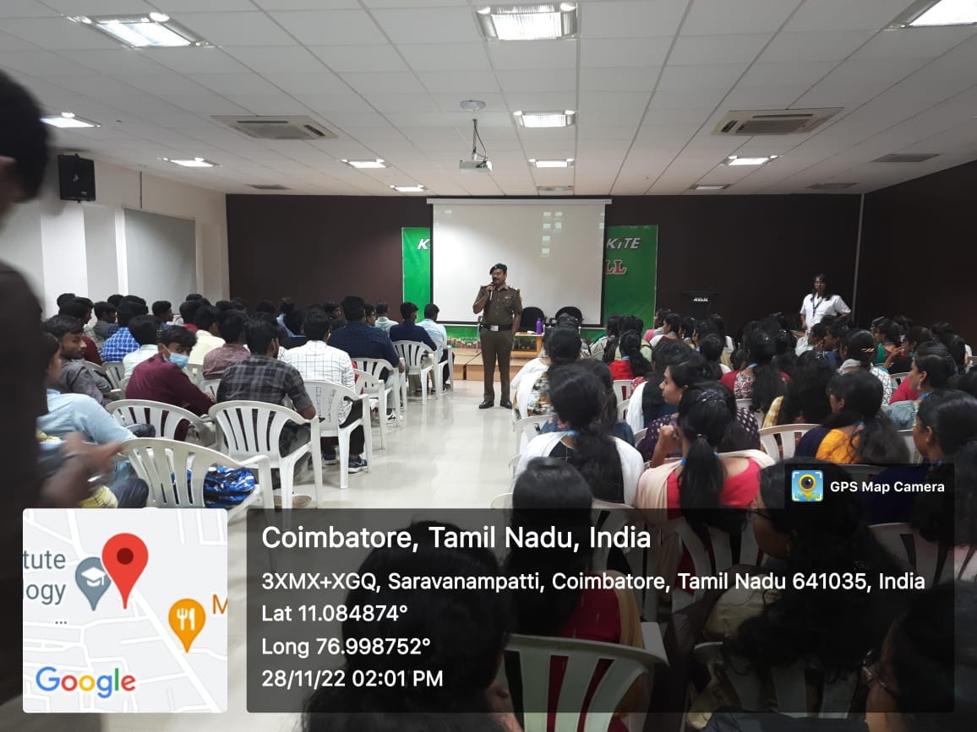
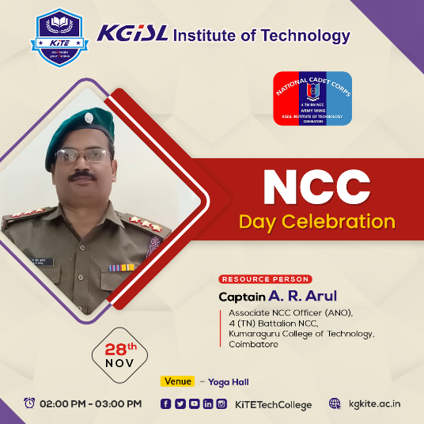
On November 28, 2022, the NCC Day was celebrated at the KGISL Institute of Technology, wherein a guard of honour was given to Captain A.R. Arul, KCT got an opportunity to be a part of the celebration

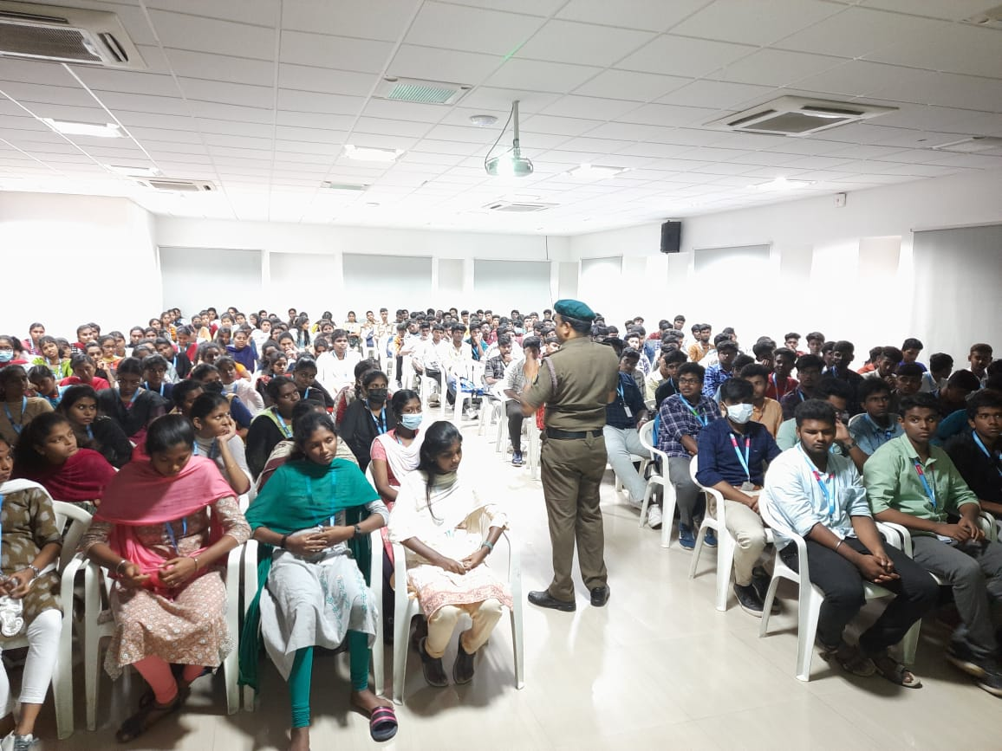
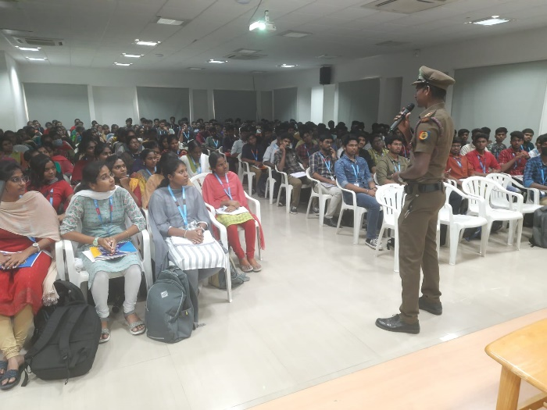
NCC Day
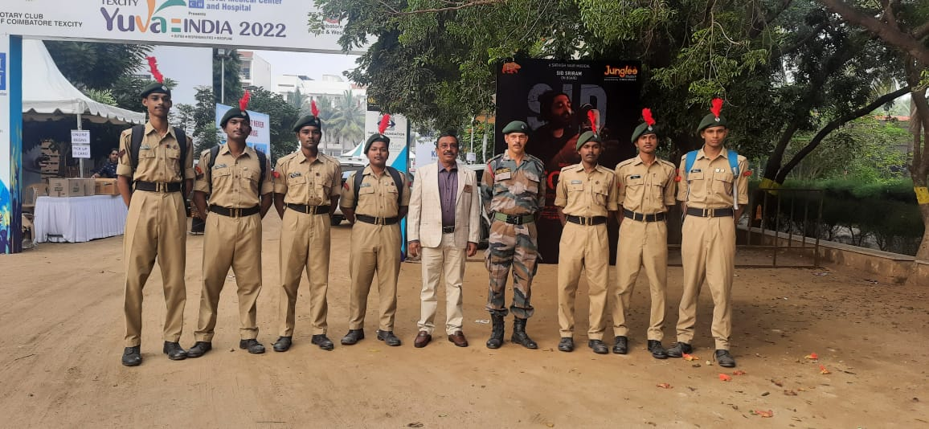
MEGA YOUTH CONFERENCE
A Mega Youth Conference, Hindustan College of Arts & Science, 16th Nov to 18th Nov 2022.

ENROLMENT
The notice was displayed on board for enrolment of the academic year 2022- 23 on 19-09-2022 & 20-09-2022. As per directions from Lt. Col B. Bharat, Commanding Officer, 04 (TN) NCC, Coimbatore, both Boys and Girls are will enrolled for first year NCC from KITE second year students. Second time selection for first year students on 26-11-2022. Totally fifty students of various classes were given the enrolment tests and on their performance basis 24 students were enrolled in the first year NCC.

BLOOD DONATION CAMP

On 03 January 2023 The NCC cadets of KGISL Institute of Technology in association with KG Hospital have made a step on a Blood Donation campaign which was held at KGISL Institute of Technology. The programme was inaugurated by the Dr. M. Selvam, Principal-KITE. Many people came willing for donating blood. 10 NCC cadets of KITE donated Blood with pride and also received certificate.
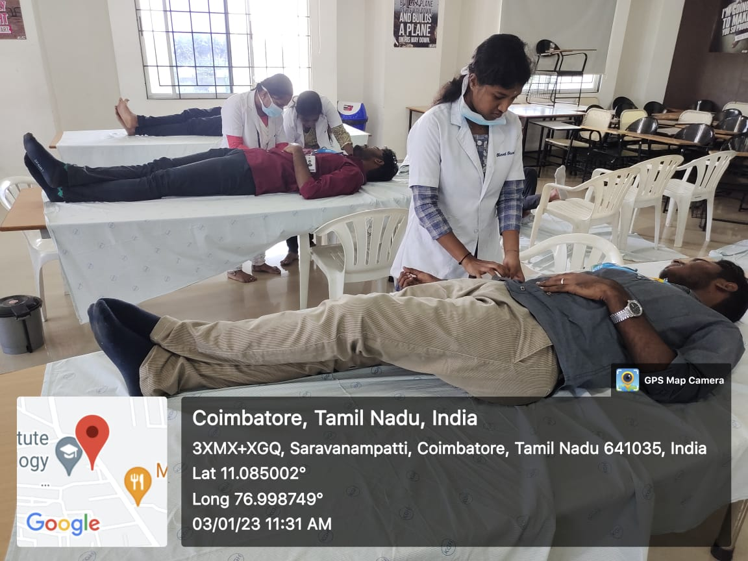
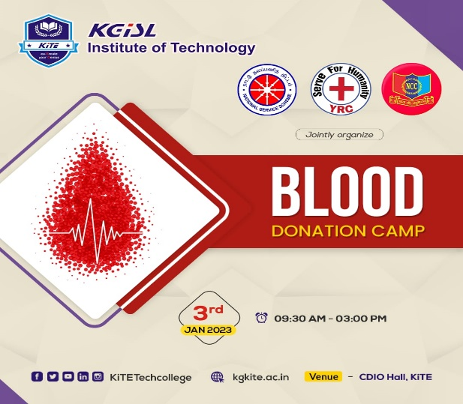
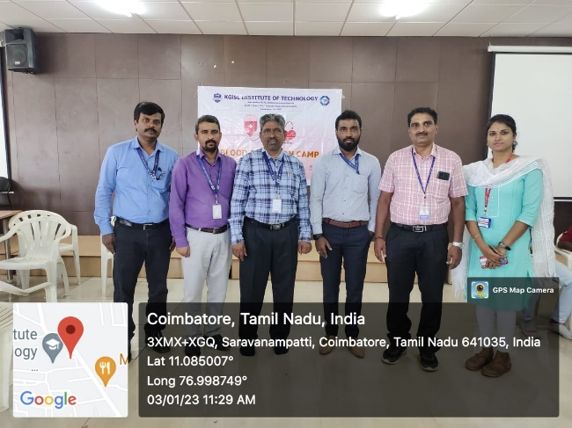
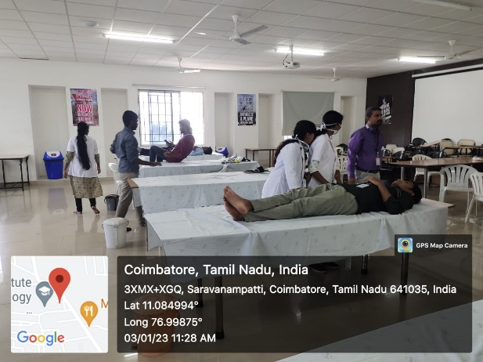

SWACHNTA CAMPAIGN
In keeping with the vision of Prime Minister Shri Narendra Modi, National Cadet Corps (NCC) has initiated a nationwide flagship campaign ‘Swachnta’ to clean seashores/beaches and other water bodies, including rivers and lakes of plastic & other waste material.
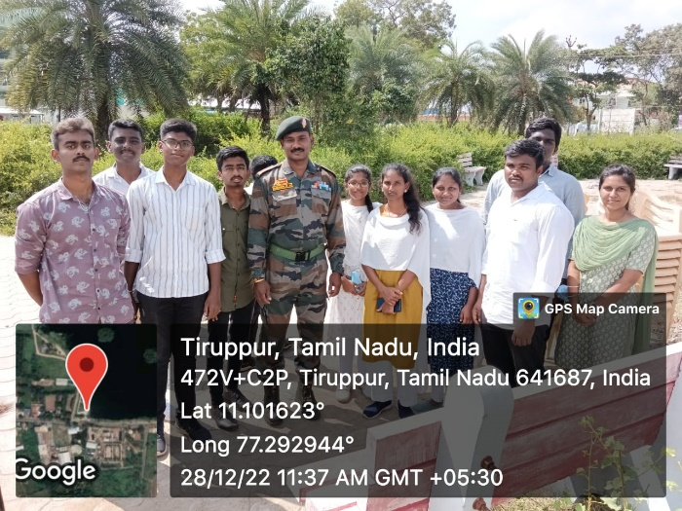
On 28 December 2022, 10 KITE NCC cadets had participated with enthusiasm and vigour in cleaning up the plastic waste at Lake, Tiruppur.
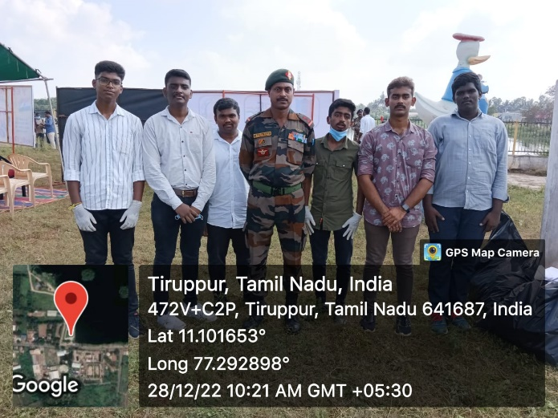
On 03 Feb 2023, 15 KITE NCC cadets had participated with enthusiasm and vigour in cleaning up the plastic waste at KGISL Ground on campaign Swachnta 2.0.
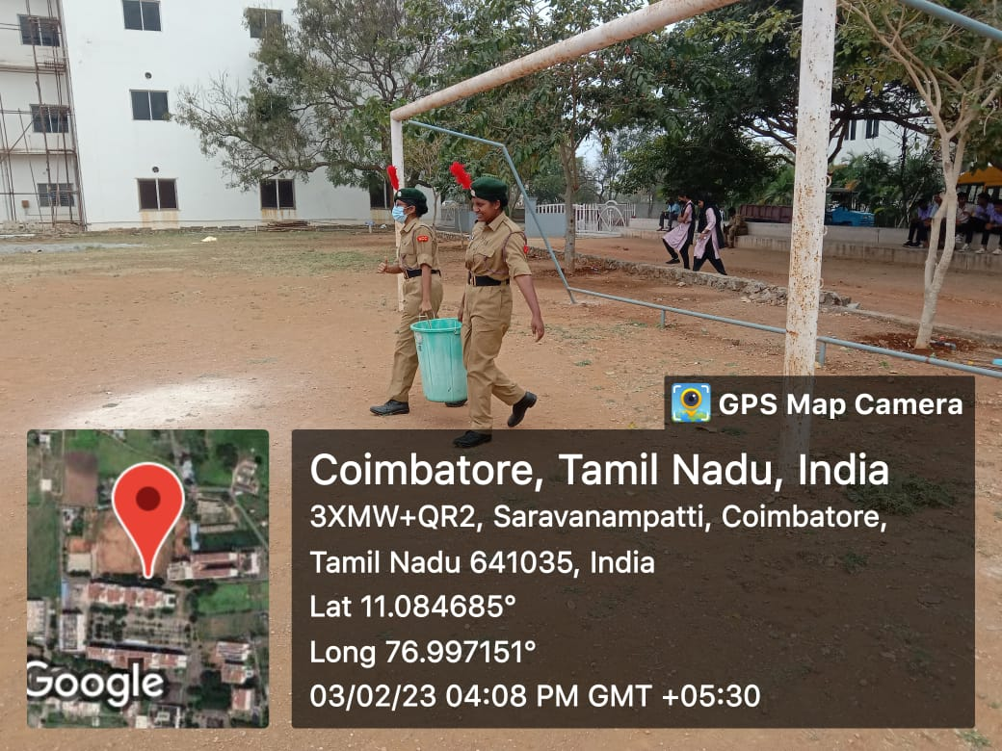
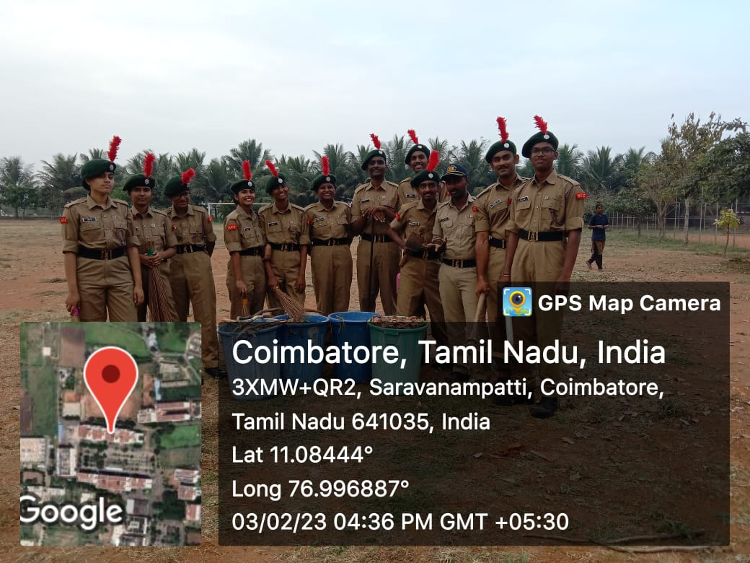

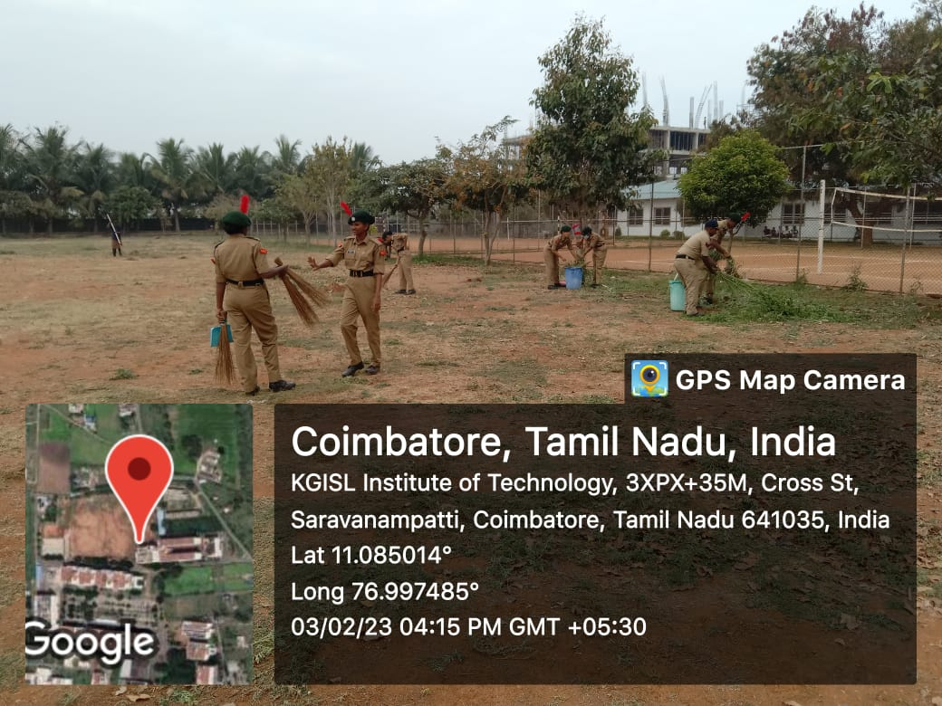
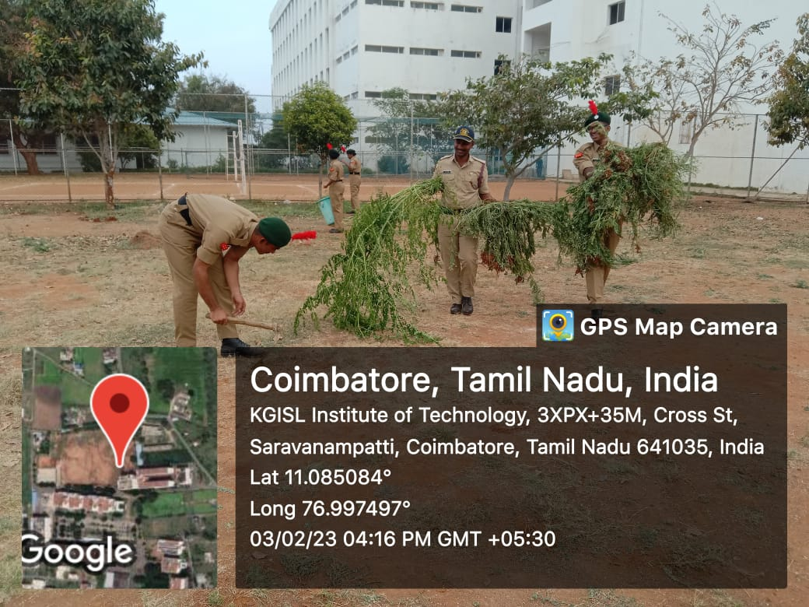
Swachnta Campaign 2.0 at KITE, Coimbatore

REPUBLIC DAY
National Cadet Corps gearing up for Republic Day celebrations which will be held in KGISL Campus, Saravanampatti on 26th January 2023. “NCC Cadets said they arrived early in the morning to participate in the parade to put their best food forward on Republic Day. NCC is providing them with all facilities including hostel facilities as a few cadets come from the remotest areas,” said one of the Cadets. The Chief Guest for the event was Dr. G. Bakthavathsalam, Chairman, KG Hospital included our Secretary, Vice Principal, All HODs, PDs and Dr. S. Vimal Kumar, PI-NCC. We looked at the rising flag and saluted it with full hope.
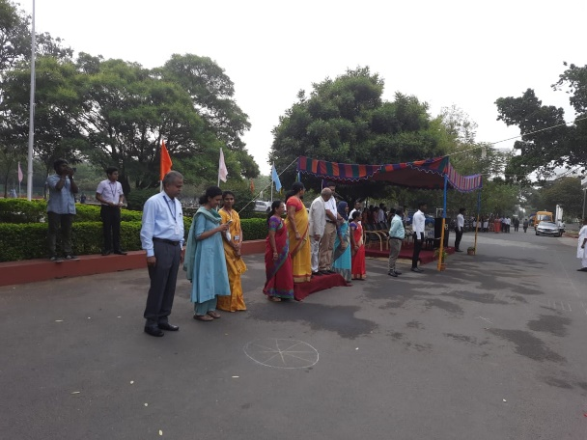
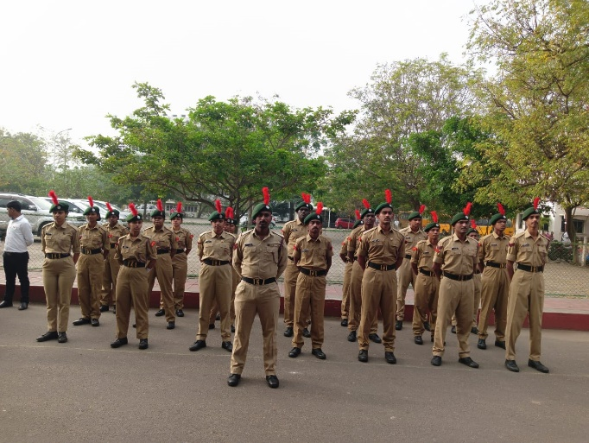
Republic Day, 26 Jan 2023
ANNUAL TRAINING CAMP
Our college, 10 cadets was attended the CATC and got the knowledge of B” Certificate Exam at Dr. Mahalingam College of Engineering and Technology, Pollachi from 25.12.2021 to 08.11.2022 and One cadet was attended at SNS College of Technology, Coimbatore. Special Rifle drill for two cadets at PSG CAS
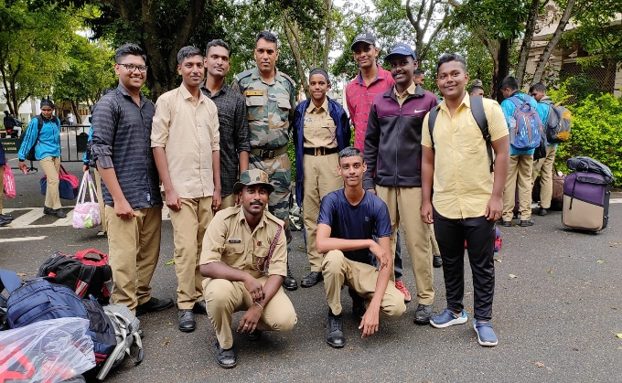
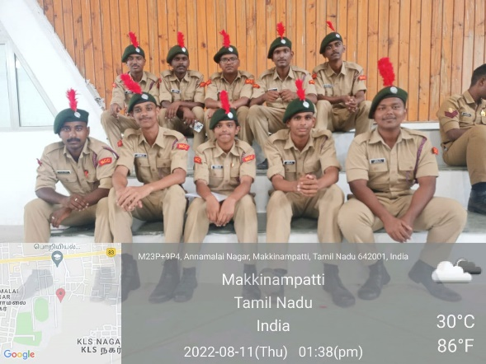

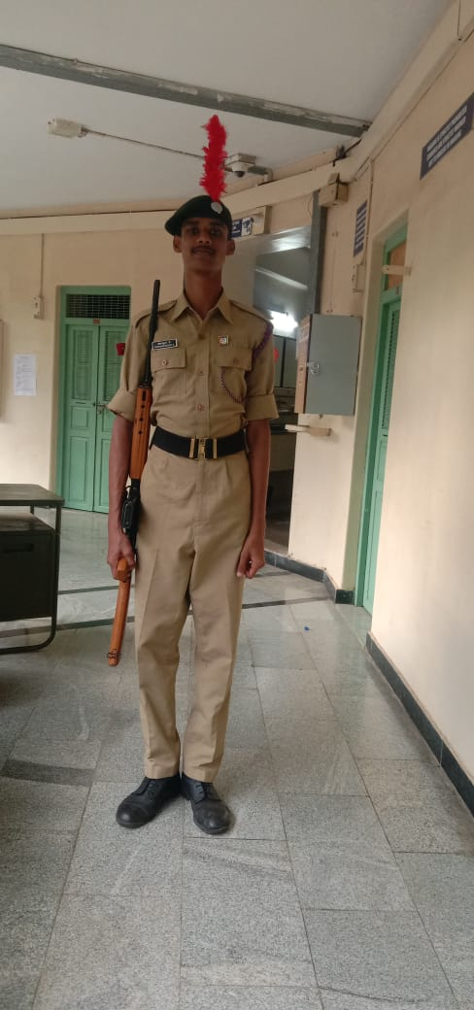
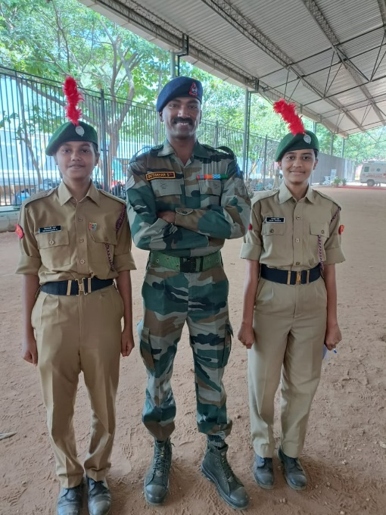
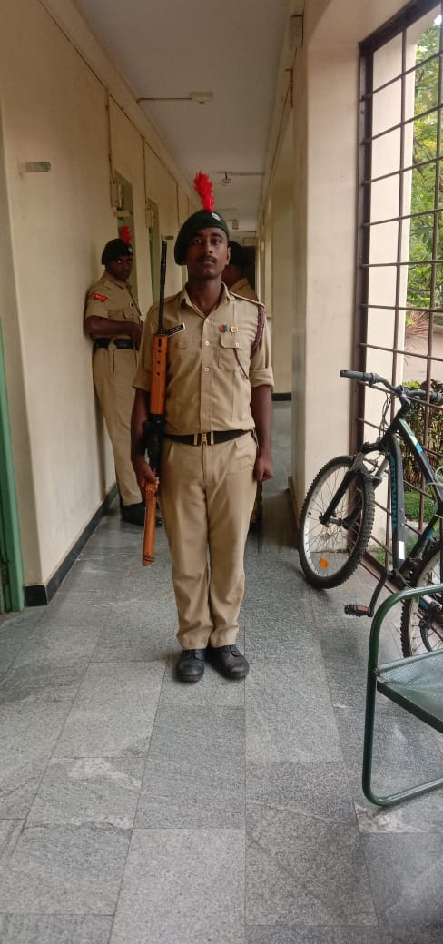

CATC Camp - ‘B’ Certificate at SNS Rifle Drill at PSG CAS

RIFLE SHOOTING COMPETITION
Our college, Four (04) NCC cadets to participate in the NCC Shooting Competition at Karunya Institute of Technology and Science. Our college, two cadets have done well in this shooting competition and CDT. FARSHA F got the First Price in SW and CDT. HARIHARASUDAN K Fourth Price in SD.
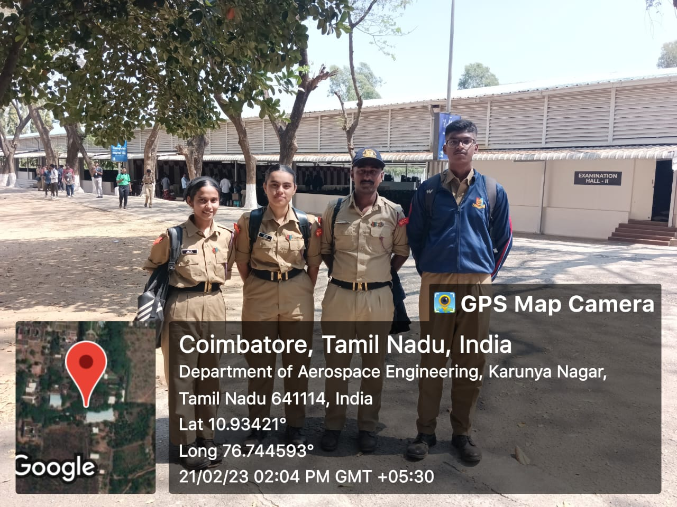

KITE SPORTS DAY
NCC cadets are participated the KITE Sports Day on 28 Feb 2023.
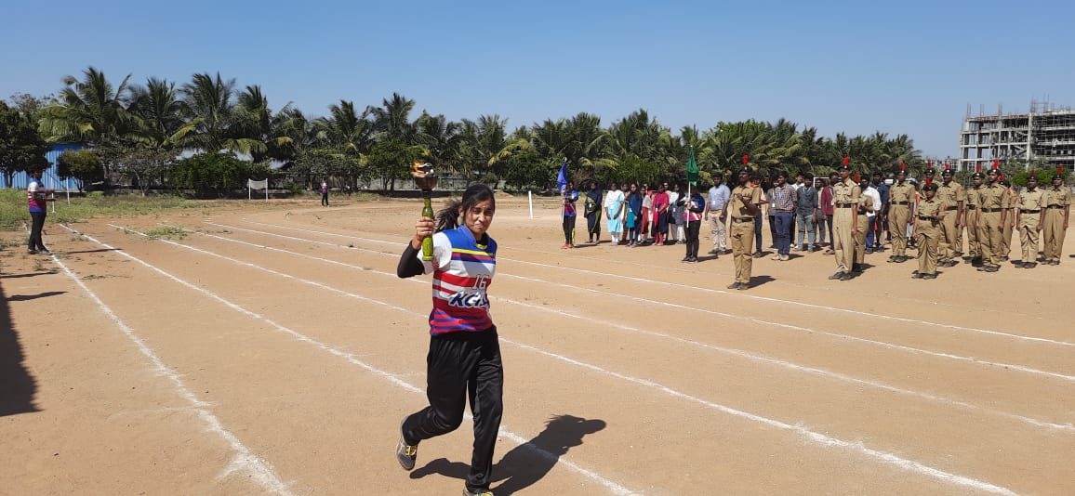
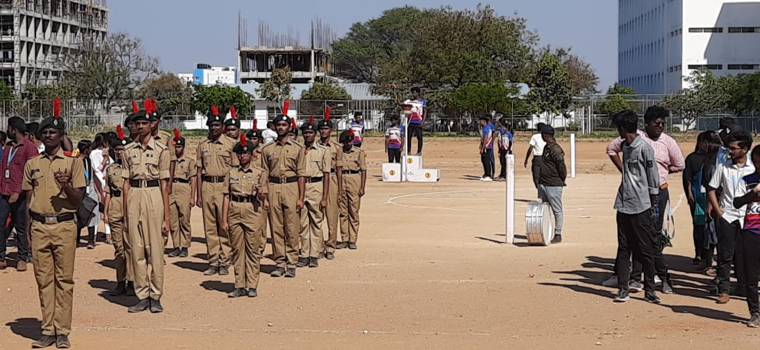

“B” CERTIFICATE CADETS
